ENGAGE PATIENT SEMINAR, VIENNA 2017
Speaker: Maude Andersson, Vice President and Editor, and Ann-Louise Storm, Social Media Responsible

GYNSAM – THE GYNAECOLOGICAL CANCER PATIENTS NATIONAL COALITION IN SWEDEN.
Established the 15th of April, 2000.
Gynsam is a nonprofit organisation that is religiously and politically independent with approx. 1000 members in Sweden. 13 member organisations from the north to the south of Sweden.
We aim to influence politicians and others in decision making positions as well as public opinion so that
- a common careplan and common guidelines are established throughout Sweden
- all women regardless of where they live shall have access to the latest and the best care available for gynaecological cancer
- preventive measures such as healthchecks and screening are developed and carried out
- all patients are offered rehabilitation

THE TOPIC IS: GENERAL CERVICAL CANCER – WHY WE CAN? WHY WE CANNOT? AND ENGAGE PERSPECTIVE?
GENERAL:
Cervical cancer is the most spread cancer worldwide today. 20 years ago this discease was most common in the western countries, but today it is the former Easten European countries, Asia, and Africa, due to economical and other reasons. Each year 3000 women suffer from any form of gyn. cancer in Sweden. Of these 3000, 1500 dies. When it comes to cervical cancer 560 women suffer from this form.
Cervical cancer is the second most common form of cancer amongst women under the age of forty-five.

WHY WE CAN?
- HPV-vaccination of girls is included in the national vaccination program in all Swedish schools (age 10-12 years). Even for girls born 1993-1998. Some counties in Sweden have free vaccinations up to 26 years of old.
- Screening will be free of charge from January 1st, 2018.
- HPV-vaccination + screening = good prognosis to avoid cancer later in life.
- Information by the gyn.cancer organisations, the professions, and the government.
- Member magazine
- Social media (Internet, Facebook, Youtube)
- Cooperation with our sister organisations in the Nordic countries.
- Translation of information about screening and vaccination to our immigrant women.
- Questionnaires
- Movie
- Brochure about side effects

- 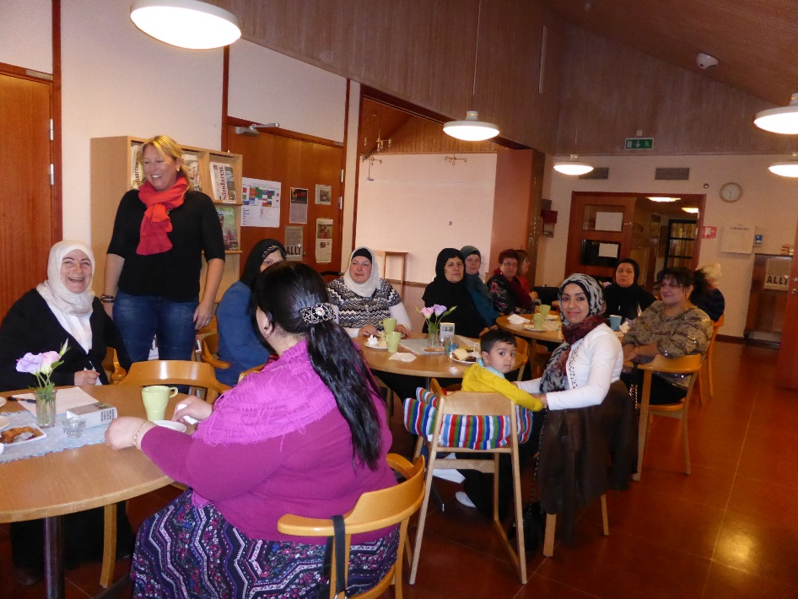

WHY WE CANNOT?
- An improved follow-up of the women neglecting the examinations
- We cannot treat rare cancer patients
- Despite many motions to the the National Board of Health and Welfare no decision has not yet been taken whether or not to give boys HPV-vaccine.
- Rumors that HPV-vaccine can cause side effects.
- Drogs are not available or is too expensive
- We don’t reach women with a psychological disease

ENGAGE PERSPECTIVE?
- Gather all gynaecologal organizations under one hat, i.e. ENGAGE – Then we will be a very strong and powerful force to count with.
- All good ideas on facebook or other social media
- Toolbox
- Medical vocabulary for dummies
- That you make sure that patient representatives get involved throughout the congress. There are many lecturers who would be interesting and instructive for us patient representatives to listen to.

Sweden 25th of October 2017
GYNSAM

